Testing for Botanical Hormesis using Monotonicity
Ying Jin, Patrick Still, Cynthia Rider, Shanshan Zhao, Daniel Zilber
January 2026

Introduction
Fruits and vegetables are widely understood to be part of a healthy diet. Perhaps surprisingly, some of the benefit from these sources of phytochemicals comes from their ability to induce a mild stress on the body at the cellular level (Son, Camandola et al. 2008). This principle can also explain mechanisms of traditional Chinese medicine and Ayurveda (Yuan, Ma et al. 2016). In some cases, the efficacy of a natural product has been studied to the point of isolating the active ingredients and characterizing their modes of action, such as opium from poppy flowers or the precursor to aspirin derived from willow bark. But in many other cases, efficacy has not been well established. This is especially the case with natural supplements sold in the US, which cannot claim a medical benefit and instead rely on traditional or cultural usage. Furthermore, even with an understanding of the mode of action, proper dosage requires further experimentation that is not typically carried out for supplements.
A direct way to measure the effect of natural products is to perform in-vitro experiments with a variety of assays, as illustrated with high-throughput screening (HTS) results from the Toxicology in the 21st Century program, or Tox21 (Thomas, Paules et al.). This data quantifies the transcriptional change due to exposures using a variety of assays that represent pathways of toxicity. Hubbard, Hsieh et al. (2019) provide a relevant contribution to the Tox21 database by evaluating a variety of common botanical products of interest to the American consumer. They fit parametric models to the HTS dose response data and report metrics like the dose at which half the maximum response is reached (EC50). They also compare extracts to purified active ingredients. Their experiments provide valuable data towards identifying potential toxicities at high doses and effects of the raw mixtures versus isolated ingredients, but the fact that a chemical increases or decreases transcription at a high dose does not provide insight into how beneficial a supplement might be at smaller doses. To better understand the health potential in this motivating data, we make use of the concept of hormesis.
Hormesis is the ability of a biological system to build strength or tolerance to toxic exposure through sufficiently small but stressful doses, and is an evolutionary adaptation that is highly conserved across plants and animals Calabrese and Mattson (2017). Two common examples of stressors that are hormetic are exercise and fasting: high “doses” are deadly, but small doses can improve health (De Cabo and Mattson). To be more precise, a common definition of hormesis is when a low dose has a stimulatory response while a high dose has an inhibitory response or vice versa (Calabrese 2014). Since the low dose effect is opposite of the higher dose effect, it is expected that the presence of hormesis suggests potential benefit. Hence, regardless of the direction of the dose response, compounds with hormesis are suitable for additional research for health benefits. Some estimates suggest as much as 40% of dose response curves from sources like Tox21 may exhibit hormesis (Calabrese and Mattson 2017), and this depends on the experimental doses being sufficiently low to observe the effect.
Searching for hormesis is often done manually by plotting a dose response curve and observing a J or inverted J shape rather than a monotonic S shape. The dip of the J is expected to range from 30-60% beyond the baseline response to be classified as hormesis (Calabrese 2014). This manual approach is fine for single chemical experiments but is not feasible for HTS with thousands of chemical-assay combinations to plot. There are also cases where the classification may be questionable due to noise in the measurements, so it is preferable to test the data directly instead of relying on visual cues.
We propose the application of a statistical test to quickly evaluate a large set of dose response data. A common approach is to fit a parametric dose response model that is flexible enough for hormesis and compare to a dose response model that is restricted to monotonic curves. The Brain-Cousens dose response model (Brain and Cousens) has extra linear terms to allow for hormesis, while setting the extra parameters to 0 will revert to a non-hormetic model. An improved model is proposed by (Cedergreen, Ritz et al. , Calabrese and Mattson 2017), which extends Brain-Cousens dose response with a nonlinear term rather than a linear term to preserve the interpretability of the slope parameter. In both models one can perform an F-test for the presence of hormesis under the null assumption that the hormesis parameter is 0. The downside to parametric methods is that they constrain the space of dose response functions, potentially misclassifying a hormetic signal. For example, some parameters may not be identified well and lead to ambiguity.
Rather than a parametric model, we make use of a shape-based test that simply evaluates monotonicity and concavity of the observed data. This approach makes minimal assumptions about the dose response curve but can still quantify uncertainty by providing a p-value for the presence of a particular curve shape. The absence of a significant p-value means there is a constant or irregular response. Our novel contribution is the application of this method to assess hormesis in botanical dose response data, along with the development of a software package to replicate this study and visualizations to summarize significance results for large sets of chemical-assay pairs.

Method and Material

Data
The data for this analysis is taken from a Tox21 data set curated for the purpose of evaluating the safety of common botanical supplements (Hubbard, Hsieh et al.). The data involves dose responses to whole plant supplement samples as well as purified active ingredients. By testing both whole and purified samples of botanicals, (Hubbard, Hsieh et al.) can identify if the response is the result of the whole-plant mixture or the result of the single active ingredient. In our context, we can evaluate if the hormetic dose response exists for the mixture or a single active molecule. There are 13 unique species and over 90 different preparations in the data set, see table 1 below.
To evaluate safety, Hubbard, Hsieh et al. (2019) employ a panel of 19 assays to cover many of the standard pathways of toxicity. Examples are the aryl hydrocarbon receptor (AhR), antioxidant response element (ARE), and aromatase receptor activity; see table 2 below.
These assays are expanded into 54 screening results, depending on reporter type (luciferase LUC, beta lactamase BLA, or viability VIA) and time course. LUC and VIA results are collected through a single channel, while BLA is collected through two channels and analyzed using the ratio. The time course assay is viability with liver or kidney cells and includes incubation periods of zero to 40 hours in 8-hour increments. Viability response increases as cell death increases. Three replicates are available for each experiment and all replicates are grouped together for analysis.

Statistical Testing
Discovering hormesis often reduces to searching for dose response curves with J or inverted J shape. Figure 1 below shows an example of an inverted J shape: a small dose interval of increasing response followed by a decreasing tail at higher doses. This J shape is mathematically described as a concave decreasing curve, and it follows that a hormetic curve can be detected by testing for concavity with a decreasing trend. For the non-inverted J shape, we look for convexity with an increasing trend. Note that testing for monotonicity is not sufficient: while all hormetic curves are non-monotonic, not all non-monotonic curves will have a J shape. Furthermore, a dose response curve may be convex or concave without having a J shape, so it is important to check for the presence of increasing/decreasing trend. A non-increasing convex curve can be observed with a Hill function response where the dose was not high enough to reach saturation. Hence, if a test shows evidence of a monotonically increasing and convex, or monotonically decreasing and concave, the shape being tested could be categorized as hormesis.
This project utilizes a shape test method by (Yin, Xun et al.): the Semi-Parametric Shape-Restricted Mixed Effects Regression Splines (SHARP). Two models are fit to the dose response data with appropriate splines, corresponding to monotonicity and convexity respectively, as follows:

$$\text{monotonicity:} y=X_{IS}β_{IS}+X_{IF}β_{IF}+Zb_{I}+ϵ_{I}$$
$$\text{convexity:} y=X_{CS}β_{CS}+X_{CF}β_{CF}+Zb_{C}+ϵ_{C}$$

The monotonicity model uses the quadratic I-spline basis $X_{IS}$Ramsay (1988), which constrains the shape of the curve to be monotonic depending on the sign of coefficients $β_{IS}$. If all coefficients are positive (negative), the curve will be monotone increasing (decreasing). $X_{IF}$ and $β_{IF}$ are potential confounders and their corresponding coefficients. $Z$ and $b_{I}$ are the random effect covariates and coefficients and $ϵ_{I}$ are random error. $b_{I}$ and $ϵ_{I}$ are assumed to follow independent zero-mean Gaussian distribution. To test the monotonicity of the curve, we focus on the I-splines coefficients $β_{IS}$ and test if they are strictly positive or negative. The test statistic is illustrated in the appendix.
The convexity equation is set up similarly, with the fixed effect component $X_{CS}$ using a cubic C-spline basis(Meyer). The C-splines constrain the curve shape just as before: when the coefficients $β_{CS}$ are positive (negative), the curve is convex (concave). Testing proceeds similarly to the monotonic model above.
The monotonicity and convexity tests compare both sets of fitted coefficients against two constraint domains. Therefore, the results will be four different p values $p_{in}$, $p_{de}$, $p_{cx}$, and $p_{cv}$. The p-values $p_{in}$ and $p_{de}$ are from testing $β_{IS}$ against non-negative and non-positive spaces respectively, thus corresponding to non-decreasing and non-increasing. Similarly, $p_{cx}$ and $p_{cv}$ are p values for convex and concave. Since we are testing four hypotheses simultaneously, we adjust for multiple comparison using the Holm method (Holm 1979), which ranks the p values and reject each hypothesis sequentially.
In practice, the null distribution of coefficient estimates, and consequently the test statistic, doesn’t have a closed-form solution. The statistic is estimated with a bootstrap method, involving drawing random samples repeatedly from the current sample. This random sampling procedure can cause different test results when the SHARP test is applied repeatedly to the same data set. When the true p value is near the significance threshold (0.05), it is likely that samples will fall on both sides of the threshold, causing an ambiguous test conclusion. Ideally there is sufficient data and/or increased iterations of random sampling to avoid the problem. Realistically, the former is difficult to achieve under resource constraints while the later will significantly increase the computation time. As a robust work around, the testing output is stabilized by implementing the SHARP test on each dose-response pairs repetitively and taking the median p-value across repetitions. An alternative is to use a “voting” rule for decision making, taking the shape with maximum votes across all repetition as the final classification. In practice, the two rules lead to nearly identical conclusions.

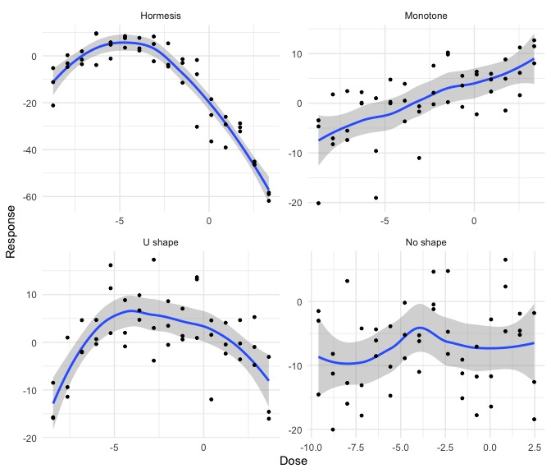
Figure 1: Ideal examples from the motivational dataset that have been classified into the four categories: a convex-decreasing hormesis curve, a monotonically increasing curve, a convex U-shape curve and a curve with unclear signals. Curves with significant monotonicity ($p_{in}<0.05$or $p_{de}<0.05$) but not convexity ${(p}_{cv}>0.05$and $p_{cx}>0.05$) are monotone, corresponding to a regular toxicity pattern. Curves with significant convexity ${(p}_{cx}>0.05$or $p_{cv}<0.05$) but insignificant monotonicity $(p_{in}>0.05$and $p_{de}>0.05$) are of U-shape. Curves that are either convex with increasing trend ($p_{cv}<0.05$or $p_{in}<0.05$) or concave with decreasing trend ($p_{cv}<0.05$or $p_{de}<0.05$) are of J-shape, indicating a possible hormetic pattern. Curves that are insignificant have no specific toxicity signals.

Scalability and Visualization
Despite the mathematical complexity, the SHARP procedure is parallelizable and efficient. This means automated evaluation of hormesis scales to large toxicology datasets with many chemical-assay pairs such as Tox21. However, SHARP returns four p values for each curve, and a large-scale toxicology data often includes a large number of curves (for example, more than 5000 curves in Tox21). It is tedious to examine these conclusions and p values curve by curve. Instead, we develop a data summarizing visualization that can provide a concise, comprehensive view of the test outputs to highlight findings.
Our novel visualization scheme presents the SHARP shape conclusions and their p values for multiple curves integrally on one 2D surface. The figure resembles a scatter plot, where each chemical-assay pair is indicated by a point. The surface is divided into four panels, representing shape classification on two different scales: convex/concave horizontally; decrease/increase vertically. The position of dose-response points is determined by the four p values from SHARP test values $p_{in}$, $p_{de}$, $p_{cx}$, $p_{cv}$ as follows:
$$\text{Vertical: }Y=I\left(p_{in}<p_{de}\right)\left(1-p_{in}\right)+I\left(p_{in}>p_{de}\right)\left(P_{de}-1\right)+I\left(p_{in}=p_{de}\right)0$$
$$\text{Horizontal: }X=I\left(p_{cv}<p_{cx}\right)\left(1-p_{cv}\right)+I\left(p_{cv}>p_{cx}\right)\left(P_{cx}-1\right)+I\left(p_{cx}=p_{cv}\right)0$$
These positioning formulas push smaller, more significant p-values toward the edges of the plot. For the pairs of opposing shapes (ie convex vs concave), only one shape can be significant at a time, so the shape with the smaller p-value is taken as the identified shape. The main axis splits the plane into the four shape classifications and the distance between points and axes shows the uncertainty of the test.
We mark out the p value significance threshold $α$ on the same scatter plot with dashed lines, which further divides the plot into a center square and eight edge regions. If a p value is smaller than $α$, meaning SHARP is able to detect a "significant" shape, then the point will be positioned on the edge regions by the layout equation shown above. On the other hand, points with insignificant shapes are positioned in the center region. Points near the edge regions and close to the significant threshold need further investigation.
Figure 2 below shows an example of visualizing test scores of Turmeric (lot90H73) between five different assays. The shape classification made by SHARP is indicated by color, and points with the same color are the repeated tests for the same dose-response data. This illustrates the variability of the repeated SHARP test. Since the replicated SHARP tests cluster tightly, using a median value is a reasonable approximation to the true p-value. For example, the pink points fall in the lower right corner beyond the significance threshold, which is the region of hormesis with concave curves with decreasing trend. The dose-response data corresponding to this assay, rt-viability-hepg2-glo-0h, is shown below in the same color and illustrates the inverted or decreasing J-shape. Similarly, teal points (rt-viability-hek293-flor-p1_0h) fall in the upper left corner, indicating hormesis with increasing J-shape. For both assays, their clusters of points fall in the same region, reflecting high certainty of shape classification. In contrast, the red cluster representing aromatase-er-aromatase-p1_luc falls on the significance boundary of concavity. This means that across repetitions, the tests conclusion alternates between concave with decreasing trend and decreasing alone. The shape may be hormetic in a general sense but a J-shaped classification is debatable.

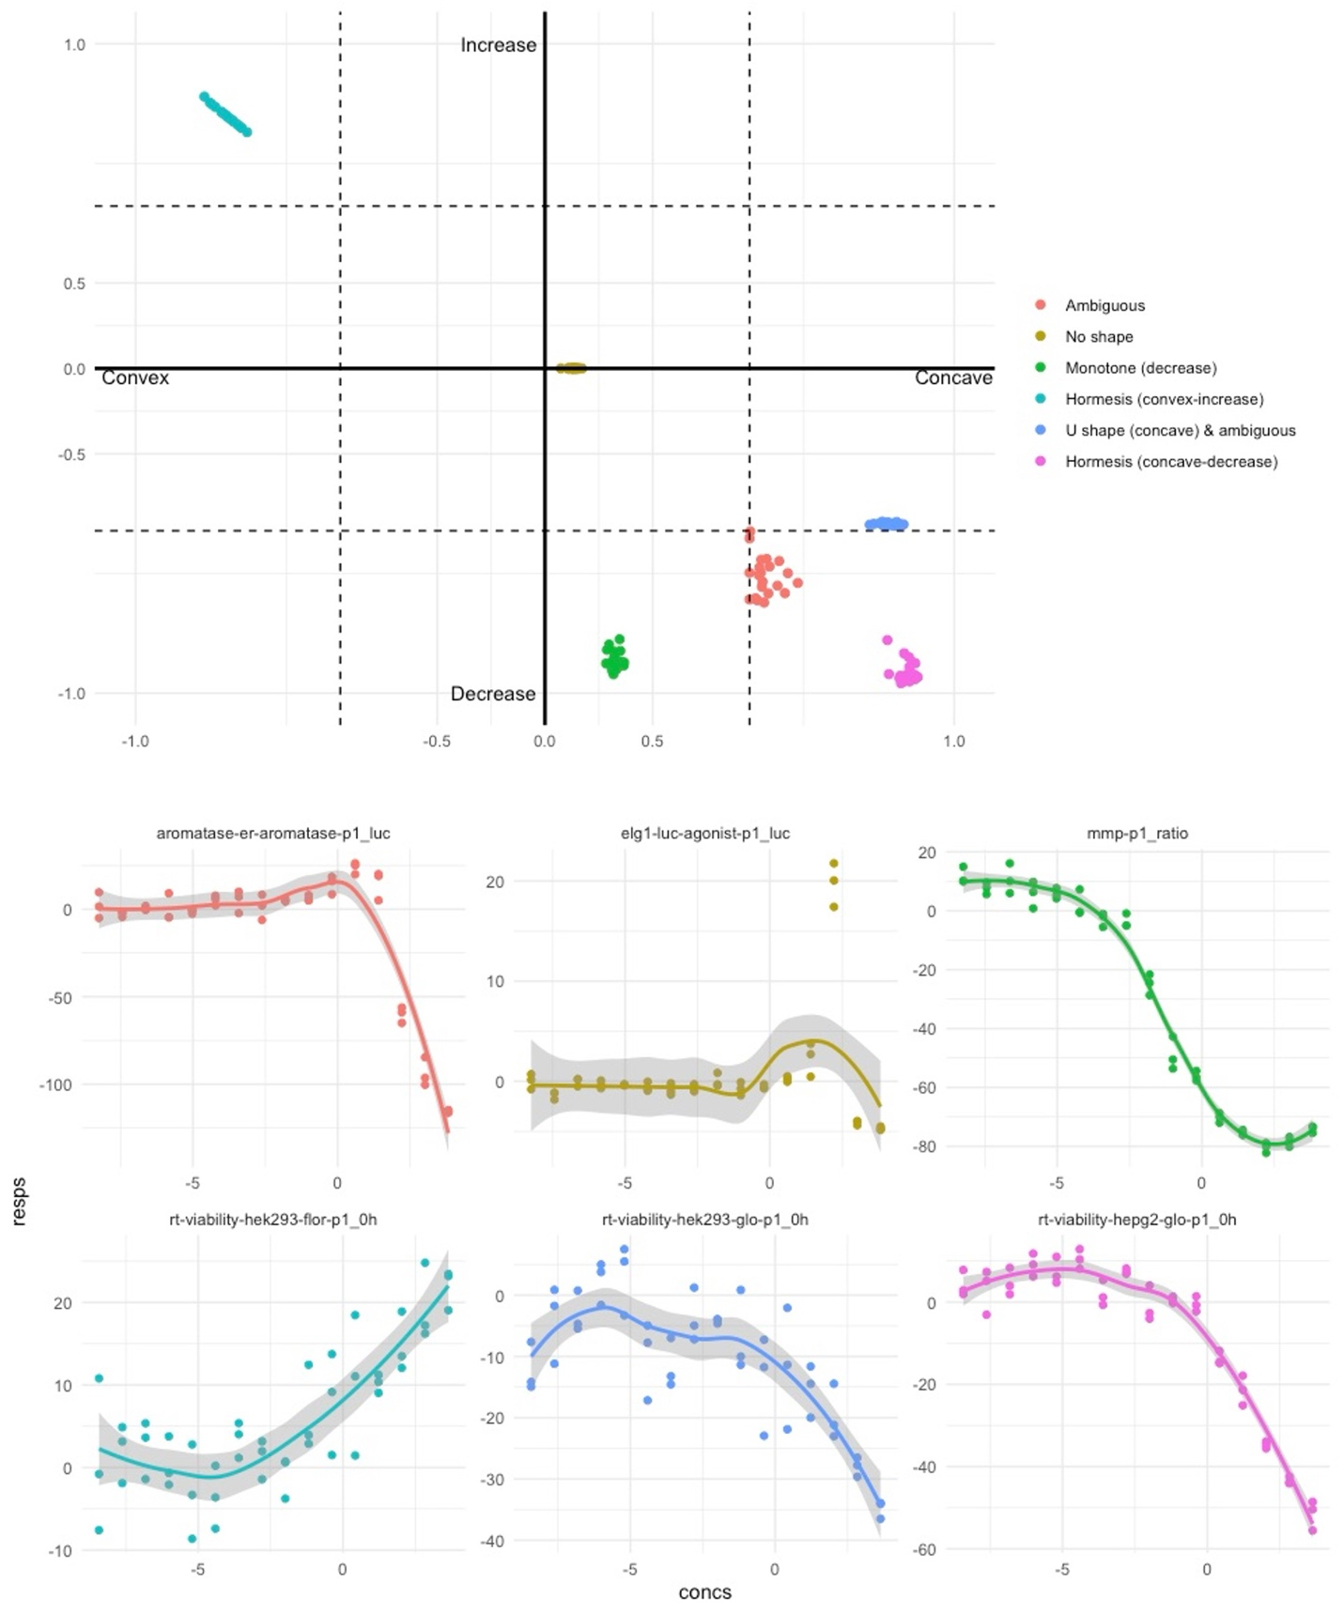
Figure 2: An example of visualizing SHARP test results of Turmeric (lot 90H73) and five assays. Each color represents a different assay with its shape classification. Points with the same color are repeated tests on the same dose-response curve

Results
Figure 1 illustrates the results of our analysis as a heatmap. The results exclude channel 1 and channel 2 from the BLA assay, since these channels represent complementary signals of cleaved and uncleaved fluorescing proteins, and the ratio is used to determine activity. There is significant structure in the figure in the form of horizontal and vertical lines. This structure implies some assays or chemicals are consistently hormetic. A large swath of assays for viability show hormesis for the turmeric botanical group and the quercetin form of gingko. Goldenseal shows consistent hormetic activity across AHR, ARE, and MMP assays, while the ARE assay also shows activity for guggul, kava kava, and citral.
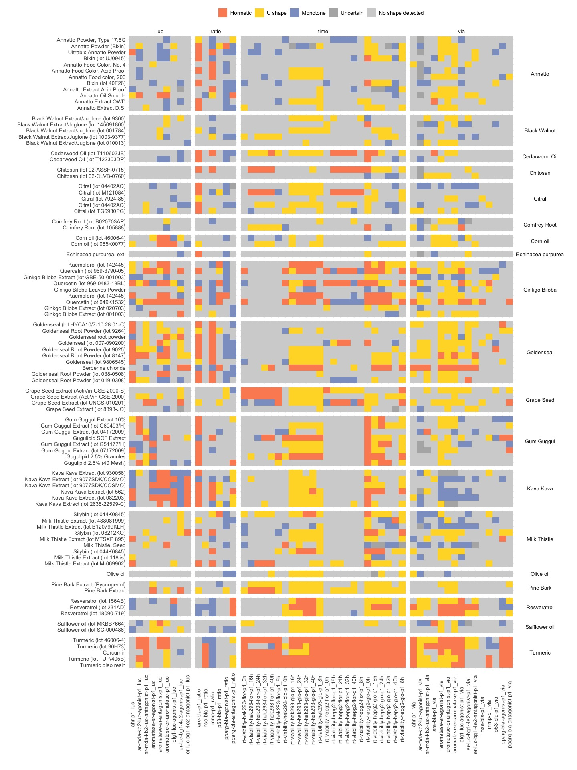
Figure 1: Results from Shape Analysis.

Summary counts for curves that are classified as hormetic are provided in tables 1, 2, and 3 below. A total of 562, or 12%, of the assays-chemical pairs tested positive for hormesis.

Botanical Group | Hormetic Curve Count (%)
Turmeric | 158 (58.52%)
Ginkgo Biloba | 91 (18.72%)
Goldenseal | 65 (12.04%)
Gum Guggul | 53 (12.27%)
Kava Kava | 39 (12.04%)
Milk Thistle | 29 (5.97%)
Resveratrol | 28 (17.28%)
Grape Seed | 24 (11.11%)
Annatto | 21 (3.24%)
Citral | 13 (4.81%)
Cedarwood Oil | 12 (11.11%)
Chitosan | 12 (11.11%)
Pine Bark | 6 (5.56%)
Corn oil | 5 (4.63%)
Comfrey Root | 2 (1.85%)
Safflower oil | 2 (1.85%)
Black Walnut | 1 (0.37%)
Echinacea purpurea | 1 (1.85%)
Olive oil | 0 (0%)
TOTAL | 562 (12%)
Table 1: Count of Hormetic Curves by botanical group. These curves test as either increasing convex or decreasing concave, suggesting a J shape curve and hormesis. Turmeric and Ginkgo showed the greatest level of hormetic activity.

Assay | Assay Type | Count | Count (Viability)
ahr-p1 | Luciferase | 16 (17.78%) | 10 (11.11%)
ar-mda-kb2-luc-agonist-p1 |  | 9 (10%) | 1 (1.11%)
ar-mda-kb2-luc-antagonist-p1 |  | 11 (12.22%) | 3 (3.33%)
aromatase-er-agonist-p1 |  | 9 (10%) | 8 (8.89%)
aromatase-er-antagonist-p1 |  | 18 (20%) | 5 (5.56%)
aromatase-er-aromatase-p1 |  | 20 (22.22%) | 8 (8.89%)
elg1-luc-agonist-p1 |  | 7 (7.78%) | 13 (14.44%)
er-luc-bg1-4e2-agonist-p1 |  | 7 (7.78%) | 4 (4.44%)
er-luc-bg1-4e2-antagonist-p1 |  | 7 (7.78%) | 3 (3.33%)
are-bla-p1 | Beta-Lactamase (Ratio) | 39 (43.33%) | 4 (4.44%)
hse-bla-p1 |  | 4 (4.44%) | 1 (1.11%)
mmp-p1 |  | 23 (25.56%) | 3 (3.33%)
p53-bla-p1 |  | 6 (6.67%) | 1 (1.11%)
pparg-bla-agonist-p1 |  | 2 (2.22%) | 8 (8.89%)
pparg-bla-antagonist-p1 |  | 6 (6.67%) | 9 (10%)

Table 2: Count of hormetic curves by assay. The antioxidant response element assay (ARE) showed the greatest count and percent of results with hormesis. The viability column represents a secondary assay performed with each primary assay cell type to measure cell death. The viability results do not correlate strongly with the assay results.

Assay (rt-viability) | 0h | 8h | 16h | 24h | 32h | 40h
hek293-flor-p1 | 9 (10%) | 9 (10%) | 9 (10%) | 10 (11.11%) | 11 (12.22%) | 13 (14.44%)
hek293-glo-p1 | 7 (7.78%) | 10 (11.11%) | 10 (11.11%) | 14 (15.56%) | 16 (17.78%) | 19 (21.11%)
hepg2-flor-p1 | 9 (10%) | 9 (10%) | 10 (11.11%) | 12 (13.33%) | 12 (13.33%) | 9 (10%)
hepg2-glo-p1 | 34 (37.78%) | 14 (15.56%) | 16 (17.78%) | 18 (20%) | 11 (12.22%) | 6 (6.67%)

Table 3: Count of hormetic curves by time course assays. The cells were treated then assayed after the time specified. Finding hormesis in these curves means there is a J-shaped curve with respect to dose for the given time point, rather than a J-shaped curve over the time period.

Turmeric occurred most often as a hormetic chemical. In addition to the time course viability assays, there was hormetic activity for the androgen and aromatase assays.
Quercetin, a flavonoid found in onions, kale and capers from the gingko botanical group, showed the next greatest activity for hormesis. Similar to turmeric, there were many hits for time course viability, aromatase, ARE, and AR, but also ELG.
The heatmap and tables provide summary views of the hormetic tests but do not allow us to compare the strength of the signals revealed by the SHARP test. Here we use our novel four-way p-value plot that shows the test statistics from the method. In figure 2 below, we illustrate the ARE assay results, showing the high frequency of convex increasing dose responses but also the relative strength (top left corner) or ambiguity (points on the dotted lines) of the shape classification.

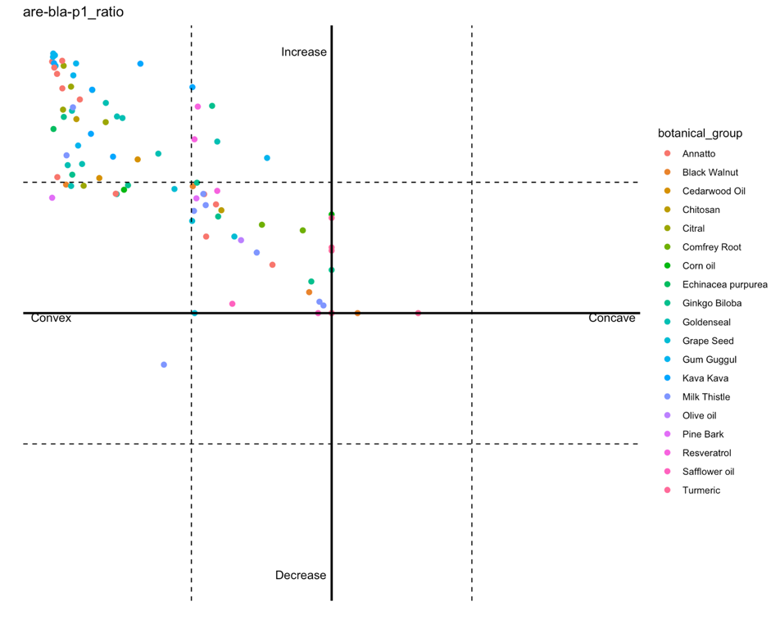
Figure 2: Shape P-value plot. Results across all shape statistics are plotted simultaneously, with the dotted line representing significance. The origin here represents a pvalue of 1 and the dotted lines intersect each axis at 0.05. The axis is linearly scaled so that the outer region corresponds to pvalues between (0, 0.05) and the inner box corresponds to (0.05, 1). Since a shape cannot be both increasing and decreasing or concave and convex, only half a plane is needed for each p-value. The antioxidant response element (ARE) assay shows many hormetic chemicals, suggesting that ARE is a common pathway for hormesis.

Potential Hormetic curves
In the heatmap shown in figure 1, hormetic assays are often surrounded by U-shaped or monotone assays. For example, the aromatase assays for goldenseal and turmeric show clusters of U-shaped and hormetic dose responses. As illustrated in Figure 3 below, the U-shaped curves could reveal hormetic dose responses with higher doses. Similarly, the aromatase assay for kava kava shows a cluster of hormetic curves mixed with monotone curves that could be hormetic with more tested doses on the lower end. Another example is the time course assay for kidney cells, hek293-glo. Looking across all botanicals, there is a trend of J-shaped curves appearing with U-shape and/or monotone curves.

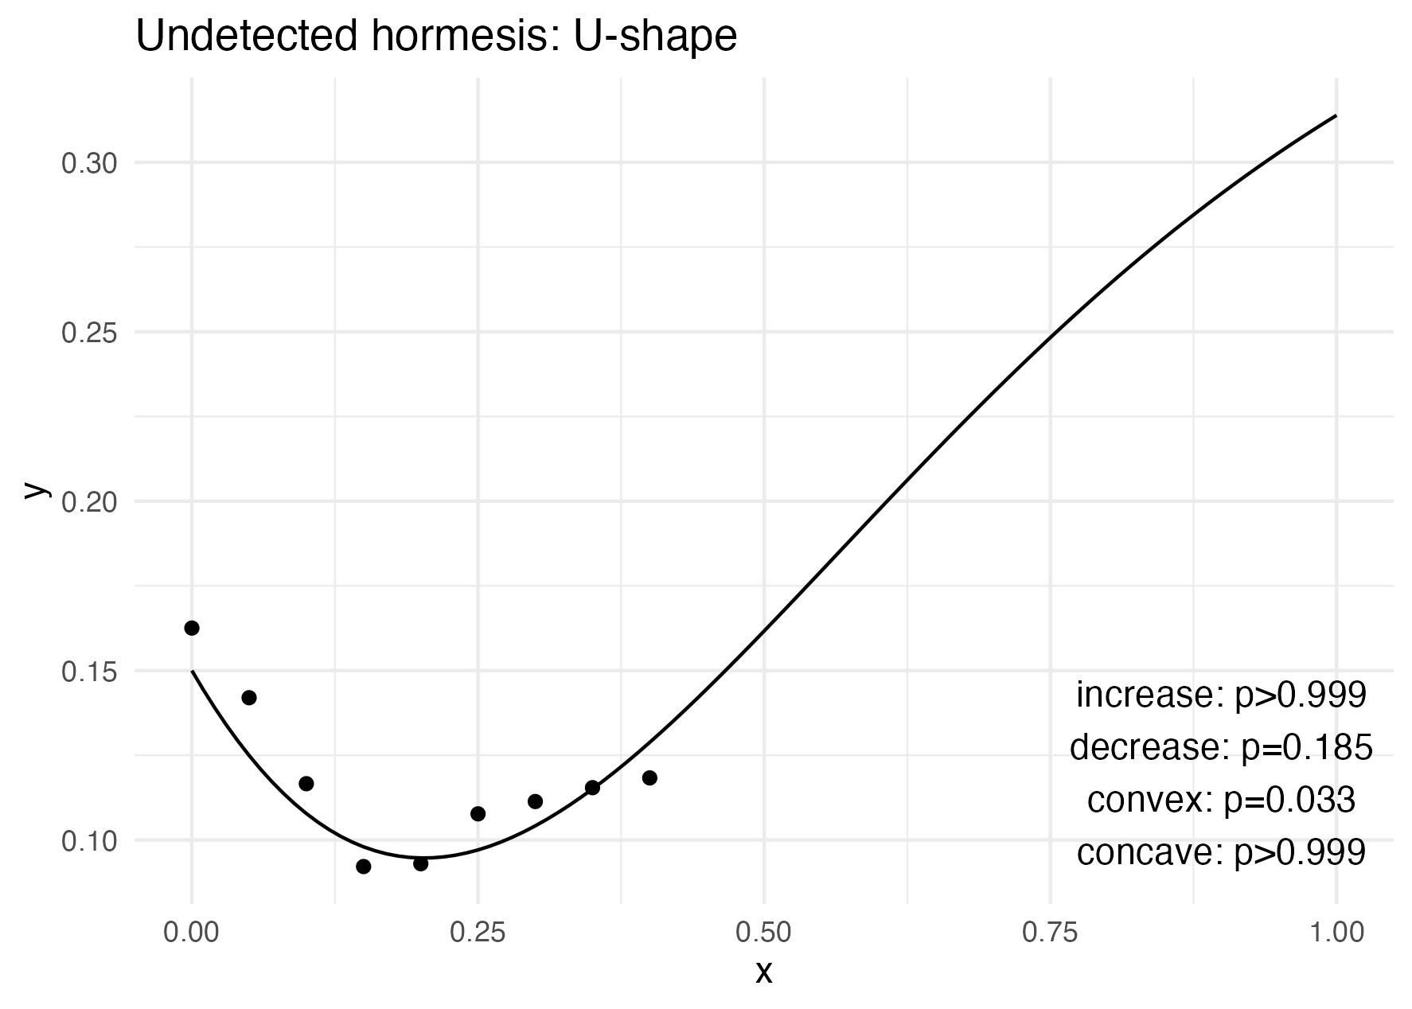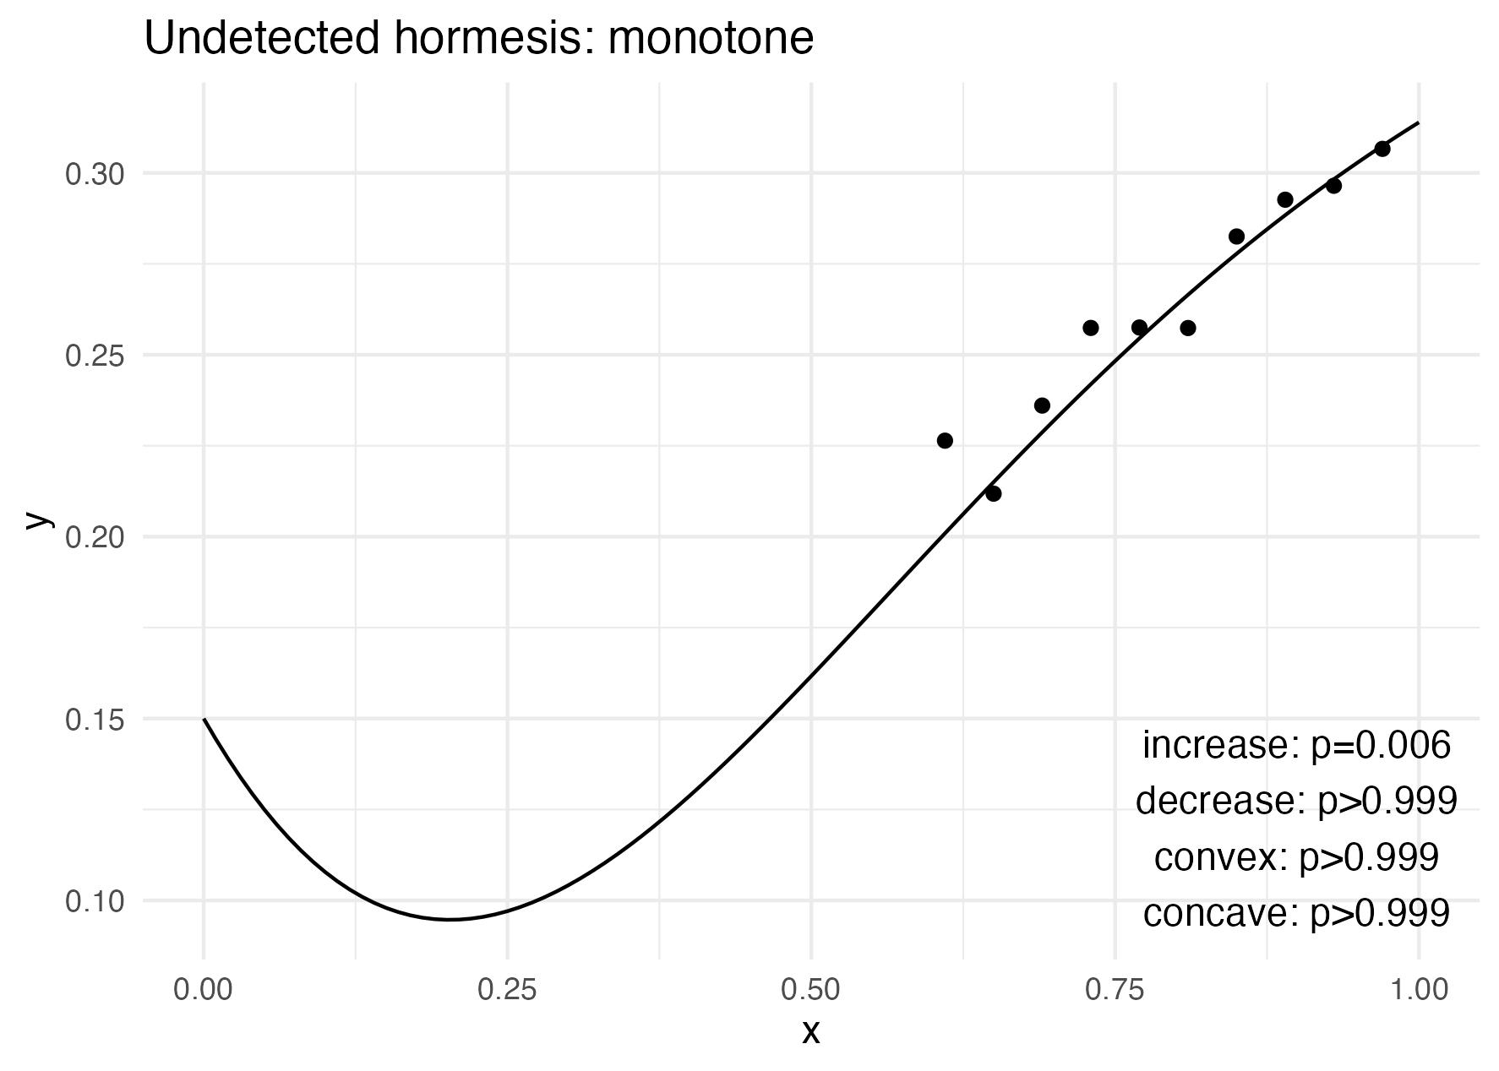
Figure 3: Potential hormetic curves. U-shaped curves may prove hormetic with higher doses while monotone curves may reveal hormesis with low doses. In some cases, intermediate doses may be missing and a monotone curve may become J-shaped if the intermediate doses are lower (or higher, for monotone decreasing curves) than expected.

Discussion
In this work we applied a statistical test called SHARP (Yin, Xun et al. 2021) to automatically determine which botanical product dose response curves exhibit hormesis. The testing procedure does not require specifying a parametric form for the dose response, which offers flexibility and avoids restrictions to very specialized formulas that allow for hormesis. Out of roughly 5000 dose response curves, we find about 500 that are significant for a J-shape, which we interpret as hormetic. This quantity of hormetic curves is in line with estimates of hormesis that is hidden in dose response repositories like Tox21.
While it has not been established that all pathways are capable of exhibiting hormesis, some are known to be relevant and consistent with our findings. For example, the stress signaling assay for the antioxidant response element (ARE) pathway is commonly associated with hormesis (Son, Camandola et al. 2008) and was a hit for many botanicals. The aryl hydrocarbon receptor (AhR) showed activity for goldenseal and is known to exhibit hormesis in the Tox21 dataset (Zhao (2021)). Endocrine disrupting chemicals are known to have non-monotonic dose responses for the estrogen receptor (ER) (Shi, Xia et al. 2022) and the androgen receptor (AR) (Klimenko 2021), and we can find examples of hormesis across both assays.
The method we propose requires some care for edge cases where one shape transitions to another. The p-values and results can be ambiguous, so we recommend review of any significant findings. The scatterplot introduced in Section 2 can greatly improve the efficiency of this examination process as it highlights all the significant results (edges) and highly ambiguous results (near significant thresholds). The SHARP test itself must perform an approximation to the test distribution to determine the p value, so there is some variability across tests and it is recommended to run the test ten to twenty times and utilize the median pvalue or the most frequent shape category returned as the mode. Specifying hormesis more precisely is a direction for future work: in addition to reducing the variability of the testing procedure with SHARP, it may be helpful to explicitly test for a J shaped curve rather than the less precise increasing-convex or decreasing-concave approach. It is also not clear how to handle replicates, where each replicate may have a different shape.
One issue we do not delve into is controlling the family-wise error rate across the combinations of assay and chemical. The SHARP method corrects for the multiple tests conducted for a specific dose response, but those tests are still specified with a significance threshold. A simple but conservative Bonferroni correction or a more precise method like Benjamini-Hochberg correction could be applied for the number of tests we are performing but is left for future work.
A natural direction for future work is the extension into mixtures of chemicals or temporal effects. Given a higher-dimensional dose response surface, it is possible that some slices will be hormetic, suggesting a beneficial proportion of ingredients. The general shape of the surface may classify as easily as the 1D cases, but it is possible that the surfaces will vary from concave to convex or increasing to decreasing and not be well defined. Temporal effects may be more difficult to ascertain but would align with the interpretation that hormesis is an increased resilience to intense stress after some initial exposure to mild stress.
Another direction for future work is further clarifying the uncertainty in the shape result. Some dose response curves show a J-shape after an initial region of no response, which does not fall into the categories we specified for hormesis. Generalizing the classification for hormesis or developing a pre-processing pipeline to isolate doses of significant behavior may improve detection results.

Appendix – Methodology Details
As described in (Calabrese 2013), hormesis is a non-monotonic dose response. A systematic way to evaluate data for evidence of hormesis is to apply a statistical test for the shape of the dose response. The shape-restricted regression spline (SHARP) (Yin, Xun et al. 2021) tests against four possible dose response shapes: increase or decreasing and concave or convex.
Their method relies on fitting the data with appropriate splines (I-splines for monotonicity, C-splines for convexity) and comparing the coefficients $\hat{β_{i}}$ to models where the coefficients are subsequently projected onto strictly positive or strictly negative domains. The test statistic is
$$T_{i}=\frac{\hat{β_{i}^{⊤}}Σ_{i}^{-1}\hat{β_{i}}-\arg{{\min_{β∈O}\left(β-\hat{β_{i}}\right)}^{⊤}}Σ_{i}^{-1}\left(β-\hat{β_{i}}\right)}{\hat{β_{i}^{⊤}}Σ_{i}^{-1}\hat{β_{i}}}$$

Theorem 1 of(Yin, Xun et al.) provides the distribution of the test statistic under the null hypothesis, so the significance (ie probability) of the test statistic can be evaluated. Note that the null hypothesis represents an unrestricted curve shape. For example, even if the basis is the monotonic I-spline, the resulting functions are not necessarily monotonic unless the coefficients are restricted to the strictly positive or negative domains. Since there are four tests computed for every curve, a Holm-Bonferroni correction is applied to the test statistics to avoid false discoveries.

Test Uncertainty
Although the SHARP method performs a test against a null distribution that is asymptotically correct, the distribution does not have a closed form that can be applied to the parameter estimates and their projections. The heart of the issue is the projection step, which compares the recovered coefficients for the various spline bases and the best fit of the constrained coefficients (ie constrained to be strictly positive or negative). Hence the distribution is approximated with 1000 bootstrap samples, introducing some uncertainty in the final estimated p-value. We repeat the test 20 times and take the median test statistic as a robust estimate of the true test statistic. While generally of little consequence, it is possible that the set of sampled p-values straddles the significance threshold, in which case there is more ambiguity about the result.

Brain, P. and R. Cousens (1989). "An equation to describe dose responses where there is stimulation of growth at low doses." Weed research 29(2).
Calabrese, E. J. (2013). "Hormetic mechanisms." Critical reviews in toxicology 43(7): 580––606.
Calabrese, E. J. (2014). "Hormesis: a fundamental concept in biology." Microbial cell 1(5): 145.
Calabrese, E. J. and M. P. Mattson (2017). "How does hormesis impact biology, toxicology, and medicine?" NPJ aging and mechanisms of disease 3(1): 13.
Cedergreen, N., C. Ritz and J. C. Streibig (2005). "Improved empirical models describing hormesis." Environmental Toxicology and Chemistry 24(12): 3166––3172.
De Cabo, R. and M. P. Mattson (2019). "Effects of intermittent fasting on health, aging, and disease." New England Journal of Medicine 381(26): 2541––2551.
Holm, S. (1979). "A simple sequentially rejective multiple test procedure." Scandinavian journal of statistics: 65––70.
Hubbard, T. D., J.-H. Hsieh, C. V. Rider, N. S. Sipes, A. Sedykh, B. J. Collins, S. S. Auerbach, M. Xia, R. Huang, N. J. Walker and et al. (2019). "Using Tox21 high-throughput screening assays for the evaluation of botanical and dietary supplements." Applied In Vitro Toxicology 5(1): 10––25.
Klimenko, K. (2021). "Examining the evidence of non-monotonic dose-response in Androgen Receptor agonism high-throughput screening assay." Toxicology and Applied Pharmacology 410: 115338.
Meyer, M. (2008). "Inference using shape-restricted regression splines." The Annals of Applied Statistics 2.
Ramsay, J. (1988). "Monotone Regression Splines in Action." Statistical Science 3.
Shi, Z., M. Xia, S. Xiao and Q. Zhang (2022). "Identification of nonmonotonic concentration-responses in Tox21 high-throughput screening estrogen receptor assays." Toxicology and applied pharmacology 452: 116206.
Son, T. G., S. Camandola and M. P. Mattson (2008). "Hormetic dietary phytochemicals." Neuromolecular medicine 10(4): 236––246.
Thomas, R. S., R. S. Paules, A. Simeonov, S. C. Fitzpatrick, K. M. Crofton, W. M. Casey and D. L. Mendrick (2018). "The US Federal Tox21 Program: A strategic and operational plan for continued leadership." Altex 35(2): 163.
Yin, Q., X. Xun, S. D. Peddada and J. J. Adibi (2021). "Shape detection using semi-parametric shape-restricted mixed effects regression spline with applications." Sankhya B 83(Suppl 1): 65––85.
Yuan, H., Q. Ma, L. Ye and G. Piao (2016). "The traditional medicine and modern medicine from natural products." Molecules 21(5): 559.
Zhao, Y. (2021). "Computational Analysis and Modeling of Tox21 AhR Activation High-Throughput Screening Assays."

